Data Analytics & Visualization
(24DSB3101)
Comparative Study of Customer Segmentation Techniques Using Clustering Algorithms
Submitted by:
Dhanusha – 240030159
Nandini – 2420030325
Lekha – 2420030334
Group Number: 3 | Section: 7
Under the Guidance of: Mrs. Swapnika

Contents
- Abstract
- Problem Statement
- Objectives
- Literature Survey
- Research Gap Identification
- Innovation
- Creativity
- Novelty
- Feasibility
- Project Workflow
- Project Plan

Abstract
- Organizations across various industries generate large volumes of customer demographic, transactional, and behavioral data that can be utilized to understand customer purchasing patterns and support data-driven business decisions.
- Traditional marketing strategies often treat customers as a single group, limiting the effectiveness of personalized marketing, customer retention, and business growth; this project proposes a comprehensive customer segmentation framework by comparing multiple clustering algorithms through data analytics and visualization techniques.
- The proposed framework utilizes three widely recognized benchmark datasets: the Mall Customer Segmentation Dataset, Customer Personality Analysis Dataset, and the UCI Online Retail Dataset, representing different customer perspectives such as demographic information, purchasing behavior, and transactional history The datasets undergo data preprocessing, including missing value handling, duplicate removal, categorical data encoding, outlier detection, normalization, and feature scaling to improve data quality and consistency.
- A detailed Exploratory Data Analysis (EDA) is performed to gain meaningful insights through dataset overview, data quality assessment, descriptive statistics, missing value analysis, duplicate record detection, outlier detection, univariate, bivariate, and multivariate analyses, correlation analysis, feature engineering, and feature selection.
- Multiple clustering algorithms, namely K-Means Clustering, Hierarchical Clustering, DBSCAN, and Gaussian Mixture Models (GMM), are implemented and evaluated for customer segmentation The performance of these algorithms is assessed using standard clustering evaluation metrics, including the Silhouette Score, Davies–Bouldin Index, Calinski–Harabasz Index, execution time, and cluster quality.
- Visualization techniques such as scatter plots, correlation heatmaps, boxplots, dendrograms, Elbow Method graphs, PCA/t-SNE visualizations, and interactive dashboards are incorporated to enhance the interpretability of clustering results A comparative analysis is conducted across all clustering algorithms, evaluating clustering accuracy, scalability, computational efficiency, and the ability to identify meaningful customer groups across demographic, behavioral, and transactional data.
- The proposed research framework integrates customer analytics, data preprocessing, exploratory data analysis, unsupervised machine learning, clustering evaluation, and data visualization into a unified analytical pipeline The project aims to identify the most suitable clustering algorithm for customer segmentation and to provide actionable business insights that support personalized marketing strategies, customer relationship management, improved customer retention, and informed business decision-making across various industry sectors.

Problem Statement
Businesses collect large amounts of customer data, but identifying meaningful customer groups can be challenging. Different clustering algorithms may produce different segmentation results. This project develops an interactive dashboard to compare multiple clustering techniques. Performance metrics and visualizations are used to identify the most suitable algorithm. The system provides customer insights to support better data-driven business decisions.

Objectives
The main objectives of this project are:
- To develop an interactive Customer Segmentation Analytics Dashboard using Python and Streamlit, applying multiple clustering algorithms such as K-Means, Mini-Batch K-Means, DBSCAN, OPTICS, BIRCH, Spectral Clustering, and Fuzzy C-Means (FCM).
- To analyze customer datasets for effective segmentation and compare clustering algorithms using Silhouette Score, Davies–Bouldin Index, Calinski–Harabasz Index, and execution time.
- To identify the most suitable clustering algorithm for a given customer dataset, then visualize customer clusters and generate meaningful customer segment profiles.
- To provide business insights that support data-driven decision-making, allowing users to download the clustered dataset and analysis report.

Literature Survey
Research Paper | Techniques Used | Purpose | Limitation
Customer Segmentation Using K-Means (2021) | K-Means | Groups customers based on behavior. | Uses only one algorithm.
Customer Segmentation Using Machine Learning (2022) | K-Means, DBSCAN | Identifies customer segments. | Limited algorithm comparison.
Comparative Study of Clustering Algorithms (2023) | K-Means, DBSCAN, Hierarchical | Compares clustering performance. | Few algorithms considered.
Advanced Customer Segmentation (2024) | K-Means, BIRCH, DBSCAN | Improves customer grouping. | Limited interactive analysis.
Customer Segmentation with Clustering (2025) | K-Means, OPTICS, FCM | Analyzes different customer groups. | No complete dashboard.

Research Gap Identification
From the literature survey, the following research gaps were identified:
- Many systems do not provide comprehensive performance comparisons using multiple metrics.
- Most solutions lack an interactive and user-friendly dashboard.
- Limited systems provide both customer segment visualization and business insights in one platform.
- Existing studies compare only a limited number of clustering algorithms.

Innovation
The proposed system introduces:
- Evaluation using multiple performance metrics and execution time.
- Interactive visualizations for easy understanding of customer segments.
- Automatic customer segment profiles and business insights.
- A user-friendly Streamlit dashboard with dataset and report download options.
- Comparison of multiple clustering algorithms in a single platform.

Creativity
The project combines multiple machine learning techniques with an interactive and user-friendly analytics platform. Key creative features include:
- Multiple clustering algorithms in one dashboard and interactive cluster visualizations.
- Algorithm performance comparison with automatic customer segment profiling.
- Business insights and recommendations with dataset and report download options, plus a simple and responsive Streamlit interface.

Novelty
The uniqueness of this project lies in integrating:
- Multiple clustering algorithms in a single platform.
- Seven techniques including K-Means, DBSCAN, OPTICS, BIRCH, Spectral Clustering, Mini-Batch K-Means, and FCM.
- Multiple evaluation metrics for accurate algorithm comparison, including execution time.
- Interactive customer segment visualizations and profiles.
- A complete interactive dashboard instead of a standalone clustering model.
- A summary section that describes a final decision.
This combination makes customer segmentation easier to compare, understand, and apply for data-driven business decisions.

Feasibility
The project is feasible because:

Technical Feasibility
- Uses open-source technologies such as Python, Streamlit, and Scikit-learn.
- Clustering algorithms and evaluation metrics are readily available through Python libraries.
- Can be developed using standard software tools.

Operational Feasibility
- Easy to use through an interactive dashboard.
- Suitable for students, researchers, and business users.
- Can run on a normal laptop.

Project Workflow
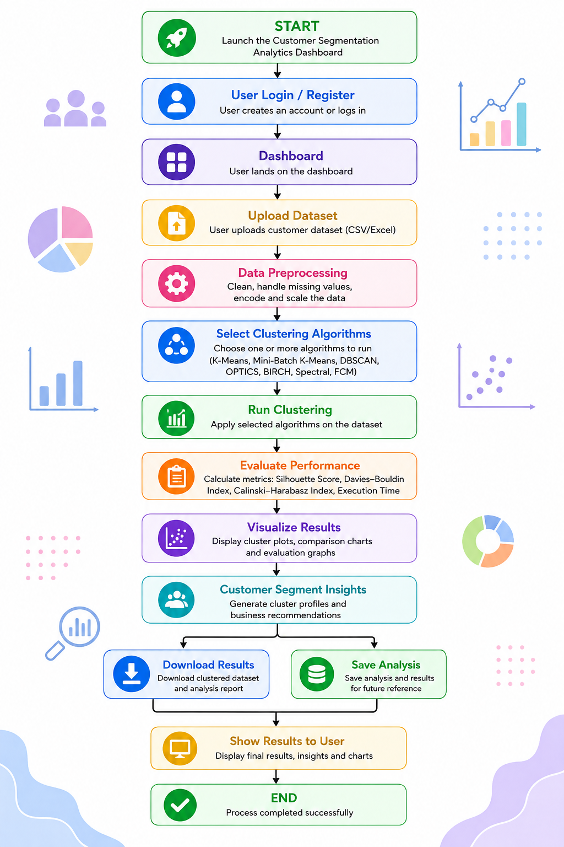
Flow Chart

Project Plan
Phase | Activity | Description
Phase 1 | Project Planning & Research | Define the project title, problem statement, objectives, literature survey, research gap, innovation, feasibility, and project plan.
Phase 2 | Methodology & System Development | Define methodology and system design, select tools and technologies, collect and preprocess data, and implement clustering algorithms and the dashboard.
Phase 3 | Results & Performance Evaluation | Analyze clustering results, compare algorithms using evaluation metrics, prepare results, and generate customer segment insights.
Phase 4 | Documentation & Final Preparation | Prepare the project report, research paper, PPT, GitHub repository, project analysis report, and demonstration video.
Phase 5 | Testing & Final Submission | Perform complete system testing, fix errors, validate results, conduct the final project demonstration, and submit all required project documents and research paper proof.

